EN Instructions for Use

ViroQ® SC2 Variant 1

Test kit for the detection of specific variants of SARS-CoV-2 RNA

Electronic instructions for use see www.bag-diagnostics.com

RUO

For research use only – do not use for diagnostic purpose.

REF 728272 ViroQ® SC2 Variant 1 RUO 96 Test
For use with
Specimen Types | RNA extraction kits /  automated extraction instruments | Real-time PCR instruments
Nasopharyngeal (NP) swabs | QIAGEN  QIAamp Viral RNA Mini QIAcube Kit /  QIAcube  Roche  Roche MagNA Pure 96 DNA and Viral NA Small Volume Kit / MagNA Pure 96 Instrument  Thermo KingFisher Thermo Fisher  MagMAX Viral/PathogenNucleic Acid Isolation Kit | Bio-Rad  CFX96 TouchTM Real-Time PCR Detection System  Roche  LightCycler® 480 System II
Oropharyngeal (OP) swabs
Nasal swabs
Anterior nasal swabs
Mid-turbinate nasal swabs

Version: 2/2021 / Issued: 2021-03

Contents
1. APPLICATION 3
2. PRODUCT DESCRIPTION 3
3. TEST PRINCPLE 3
4. MATERIAL 3
4.1 Content of the ViroQ® SC2 Variant 1 kit 3
4.2 Additionally required reagents and devices 4
4.3 Validated cyclers and reaction tubes 4
5. STORAGE AND STABILITY 5
6. TEST PROCEDURE 5
6.1 Safety conditions and special remarks 5
6.2 RNA Isolation 5
6.3 Reagent preparation 6
6.4 Amplification 6
6.5 Cycler settings 7
6.6 Interpretation of results 8
7. WARNINGS AND PRECAUTIONS 11
8. LIMITATIONS OF THE METHOD 11
9. INTERNAL QUALITY CONTROL 12
10. TROUBLESHOOTING 12
11. TRADEMARKS USED IN THIS DOCUMENT/PRODUCT 12
12. EXPLANATION OF SYMBOLS USED ON THE LABELS 13
13. LITERATURE 14

APPLICATION
The ViroQ® SC2 Variant 1 Kit is used for qualitative detection of SARS-CoV-2 RNA variants (UK B.1.1.7; ZA B.1.351; BR P.1; BR P.2; BR B.1.1.28; according to RKI B.1.1.7, B.1.351 and P.1 are worrying SARS-CoV-2 virus variants (17.02.2021). RKI - Coronavirus SARS-CoV-2 - Übersicht und Empfehlungen zu besorgniserregenden SARS-CoV-2-Virusvarianten (VOC).) and the correcsponding spike protein mutation in respiratory specimens such as nasopharyngeal (NP), oropharyngeal (OP), nasal, anterior nasal and mid-turbinate nasal swab based on reverse transcription of the RNA and subsequent amplification in real-time PCR.

For research use only – not for diagnostic purposes.

PRODUCT DESCRIPTION
The ViroQ® SC2 Variant 1 kit is based on a one step reaction with real-time PCR technology with a compromised PCR protocol (≤ 1h). An efficient cDNA synthesis from RNA coupled with a real-time PCR the ViroQ® SC2 Variant 1 Kit makes it possible to perform the test in one tube. The kit is containing primers and fluorescent probes to amplify and detect gene fragments for SARS-CoV-2 and its variants.

TEST PRINCPLE
The test is performed with RNA as starting material. The RNA is converted into cDNA with a reverse transcriptase enzyme and afterwards amplified in a PCR. The primers were designed for the generic amplification of the trancripted cDNA of the viral RNA. The SARS-CoV-2 variants are detected with likewise specific fluorescent dye-labelled hydrolysis probes (TaqMan® probes) (https://dx.doi.org/10.15585%2Fmmwr.mm7003e2).
The specific probes are hydrolyzed by the Taq polymerase and a fluorescence signal is generated that increases proportionally to the amount of the PCR product. The fluorescence signals are measured by the optical detection unit of the RT-PCR-Cycler.
The test is performed in one PCR reaction that detects the different present variant with different flourescent colors.

MATERIAL

Content of the ViroQ® SC2 Variant 1 kit
- ViroQ|ENZYME ViroQ® Enzyme, lyophilized, contains Reverse Transcriptase,
Taq Polymerase, dNTPs
- ViroQ|SOLV ViroQ® Solvent, ready to use, contains reconstitution buffer for the ViroQ®
Enzyme
- ViroQ|MIX ViroQ® Mix V1, ready to use, contains, Primers, Probes, Storage buffer
- IFU or eIFU Instructions for use or electronic instructions for use

Additionally required reagents and devices
- Reagents for RNA isolation (validated RNA isolation kits see 6.2)
- Real-time PCR-Cycler (validated cyclers see 4.3)
- RT-PCR reaction tubes with caps or foils (validated products see 4.3)
- RNase free H₂O
- Piston pipettes (0,5 – 1000 µl) and tips

4.3 Validated cyclers and reaction tubes
Cycler | real-time-PCR reaction tubes | real-time-PCR  closing system
CFX96 Touch™ Real-Time PCR Detection System  Comp. Bio-Rad | Vari-Strip™ 8 Well PCR Tube Strips  Product No. 4ti-0753  Comp. 4titude / Brooks Life Sciences | Crystal StripsTM  Product No. 4ti-0755/120  Comp. 4titude / Brooks Life Sciences
CFX96 Touch™ Real-Time PCR Detection System  Comp. Bio-Rad | FrameStar® Break-A-Way PCR Plate, Low Profile, 96 white wells, black frame  Product No. 4ti-1201  Comp. 4titude / Brooks Life Sciences | qPCR Seal  Product No. 4ti-0560  Comp. 4titude / Brooks Life Sciences
LightCycler® 480 System II  Comp. Roche | LightCycler® 480 Multiwell Plate 96, white  Product No. 04729692001  Comp. Roche | qPCR Seal  Product No. 4ti-0560  Comp. 4titude / Brooks Life Sciences
LightCycler® 480 System II  Comp. Roche | Vari-Strip™ 8 Well PCR Tube Strips  Product No. 4ti-0753  Comp. 4titude / Brooks Life Sciences | Crystal StripsTM  Product No. 4ti-0755/120  Comp. 4titude / Brooks Life Sciences

Special Note: If other realtime cyclers, reactions tubes and closing systems are used they must be validated by the user.

STORAGE AND STABILITY
The kits are shipped without cooling. Upon receipt store all reagents in temperature monitored devices at ≤ -20 °C. The expiry date is indicated on the label of each reagent. The expiry date indicated on the outer label refers to the reagent with the shortest stability contained in the kit. The reagents ViroQ® Enzyme and ViroQ® Solvent can be stored at room temperature until expiry date, as long as the enzyme lyophilisate is not solved with the reconstitution buffer. After solving it can be used upon 12 month. Repeated thawing and freezing of reagents (more than twice) should be avoided, as this might affect the performance of the assay. In terms of intermittent use the reagents should be aliquoted.

TEST PROCEDURE

Safety conditions and special remarks
Molecular genetic techniques are particularly sensitive and should be performed by well trained personnel experienced in molecular genetic techniques.

Special safety conditions must be observed in order to avoid contamination and thus false reactions:
♦ Wear gloves during work (powder-free, if possible).
♦ Use new tips with each pipetting step (with integrated filter).
♦ If possible, use separate working areas for pre-amplification (RNA isolation and PCR set up) and post-amplification (detection).
♦ Use devices and other materials only at the respective places and do not exchange them.

RNA Isolation
The sample material for the isolation of RNA must be sent in appropriate cell collection systems.
For RNA isolation use appropriate RNA isolation kits.

Validated RNA isolation kit:

- QIAamp® Viral RNA Mini QIAcube Kit
- Roche MagNA Pure 96 DNA und Viral NA Small Volume Kit
- Thermo KingFisher Thermo Fisher, MagMAX Viral/PathogenNucleic Acid Isolation Kit

If the established standard method of the lab is used for RNA isolation and this is not the above mentioned kit, it must be validated by the user.

Reagent preparation
ViroQ® Enzyme
The enzyme mix reagent ViroQ® Enzyme is lyophilized. Before use dissolve ViroQ® Enzyme with
400 µl ViroQ® Solvent by pipetting up and down.

Amplification
Reaction tubes recommended by the manufacturer of the realtime cycler or the materials recommended in chapter 4.3 should be used.

For each sample the following reagents are pipetted into a reaction tube:

Reaction
4 µl ViroQ® Enzyme
2 µl ViroQ® Mix V1
5 µl* RNA sample
5 µl RNase free H₂O

*In case of very low expected concentration of virus copies the volume of the sample can be increased, while decreasing the amount of water.

The reaction volume for each real-time PCR test is 20 µl.

If a premix of ViroQ® Enzyme, ViroQ® Mix V1 and RNase free H₂O is prepared for more than one sample please allow for a reasonable additional amount for pipetting losses.

To perform a no template control (NTC) prepare a PCR reaction and use RNase free H₂O for the negative control instead of RNA.

Close the reaction tubes and briefly spin down the liquid. Ensure that no bubbles are present in the wells. If bubbles are observed, gently tap the reaction tube on the bench to remove the bubbles.

Start the PCR program with the following parameters:
Step | Time | Temperature | No. of cycles
Reverse Transcription | 8 min | 48°C | 1 cycle
Polymerase activation | 2 min | 96°C | 1 cycle
Denaturation | 2 sec | 95°C | 42 cycles
Annealing + Extension | 10 sec + reading | 64°C | 42 cycles
The following real-time cyclers have been validated for the ViroQ SARS-FluA/B-RSV kit. Please note the cycler-specific settings described under 6.5 Cycler settings:
Biorad: CFX96 Touch™ Real-Time PCR Detection System
Roche: LightCycler® 480 System II

Special Note
• If other realtime cyclers are used they have to be validated by the user.

Cycler settings

Bio-Rad CFX96 Touch™ Real-Time PCR Detection System

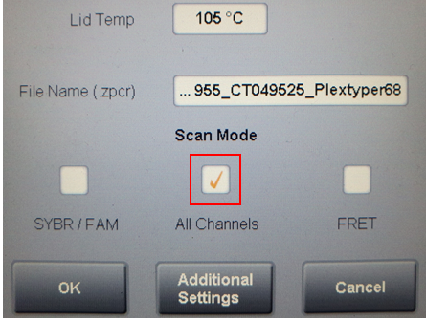
For use on the CFX96 Touch™, the following specific settings must be made. Before starting the run, a check mark must be set for “All Channels”. The lid temperature is set to 105°C.The default ramp rate is used.

Roche LightCycler® 480 II

For use on the LightCycler® 480 II, the following specific settings must be made. When programming the PCR program, the corresponding ramp rate must also be set.

Step | Time | Temperature | Ramp rate | No. of cycles
Reverse Transcription | 8 min | 48°C | 4,4°C/s | 1 cycle
Polymerase activation | 2 min | 96°C | 4,4°C/s | 1 cycle
Denaturation | 2 sec | 95°C | 2,2°C/s | 42 cycles
Annealing + Extension | 10 sec + reading | 64°C | 2,2°C/s | 42 cycles

The following filter settings must be made:

Excitation Filter | Emission Filter | Name | Melt Factor | Quant Factor | Max Integration Time (sec)
597 | 616 | Texas Red | 1 | 10 | 1
495 | 520 | FAM | 1 | 10 | 1
535 | 556 | HEX | 1 | 10 | 1
646 | 669 | Cy5 | 1 | 10 | 1

To get to the filter settings, please carry out the following steps.
Go to Tools → Detection Formats → Select Assay → set the settings for example Quantfactor to 10

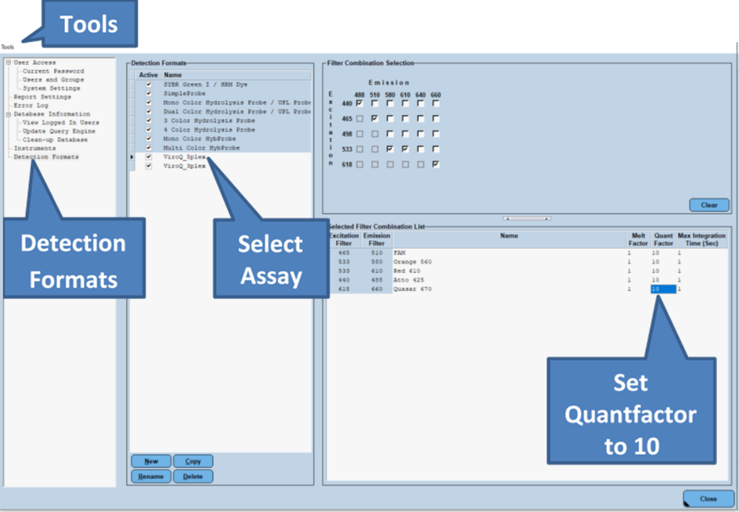

Interpretation of results

For all reactions in the multiplex PCR mix a Ct cutoff is used to define positive reactions. If the Ct-value is inconclusive it can be helpful to review the fluorescent curves.
The detection reactions in the individual mixes are characterized by a maximum of three reactions in the different color channels. Background reactions may occur in other color channels (see figures at the end of the chapter). In the ViroQ® Mix V1, this was observed in the motifs 484E (Texas Red) vs. 484K (Cy5). The background reaction always appears to be significantly weaker in comparison to the specific reactions. It is recommended to increase the threshold for these reactions to suppress the Ct value.

The amplification signals for SARS-CoV-2 negative samples should be outside the defined Ct-values for all channels.

The negative control (NTC) is used as contamination control. If RNA or contaminating amplicon is inadvertently added to the NTC reaction a positive signal will occur. If the Ct is less than 35 it should be considered as possible contamination. Amplification signals above Ct 35 in the NTC could be PCR artefacts and can be disregarded taking into consideration the final RFU and the shape of the curve (see also below for interpretation of results between Ct 35 and Ct 42). If PCR contamination is suspected, it is advisable to follow local decontamination guidelines and to exchange the reagents
For valid results all Ct values ≤ 35 are rated as positive (see table below).
ViroQ® Mix V1 | Channel | Ct-Level | Inspect | Wave lenght in nm
484E | Red  (Texas Red) | ≤35 | >35-45 | Excitation: 597  Emission: 616
1176F | Green  (FAM) | ≤35 | >35-45 | Excitation: 495  Emission: 520
501Y | Orange  (HEX) | ≤35 | >35-45 | Excitation: 535  Emission: 556
484K | Rot  (Cy5) | ≤35 | >35-45 | Excitation: 646  Emission: 669

Regardless of the Ct values a positive reaction should have a sigmoidal curve and a sufficient end RFU. The RFU is cycler dependent – the final RFU of the positive control can be used to get the approximate value that is normal for the final RFU on a given cycler. The positive control can also be used as an example for the correct sigmoidal shape of the curve. Therefore, samples with a Ct value of > 35 and low RFU should be checked for a sigmoidal shape of the curve and the plausibility of the reaction. Samples with a inconclusive result should be repeated. If there are questions regarding the adaptation of the threshold or borderline Ct values please contact the technical support of BAG Diagnostics (phone: +49 (0)6404 925125, email: info@bag-diagnostics.com) or your local sales representative.
The following table shows the interpretation of the amplification results:
ViroQ® Mix | Spike Protein Variation | Dye | UK  B.1.1.7 (22,8%)* | ZA  B.1.351 (1,3%)* | BR  P.1 (0,1%)* | BR  P.2 (<1%)** | BR  B.1.1.28 | Wild type**
1 | 484K | Cy 5 |  | X | X | X
1 | 484E | Texas Red | X |  |  |  | X | X
1 | 501Y | HEX | X | X | X
1 | 1176F | FAM |  |  | X | X | X
* Report RKI 17.02.2021 2. Bericht zu Virusvarianten von SARS-CoV-2 in Deutschland, insbesondere zur Variant of Concern (VOC) B.1.1.7 (rki.de).

**Stated 26.02.2021 PANGO lineages (cov-lineages.org).

Example for a positive raction of B.1.1.7 | Example for a positive raction of B.1.351
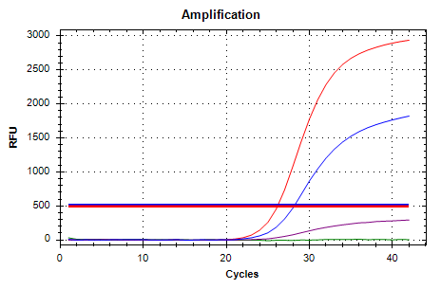  Texas Red = Red  HEX = Blue  Cy5 = Purple → Background reaction | 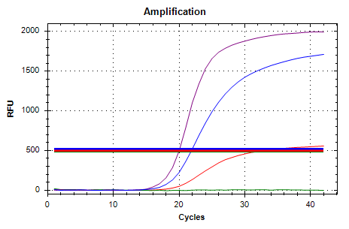  Texas Red = Red → Background reaction  HEX = Blue  Cy5 = Purple

Example for a psoitive reaction of wild type
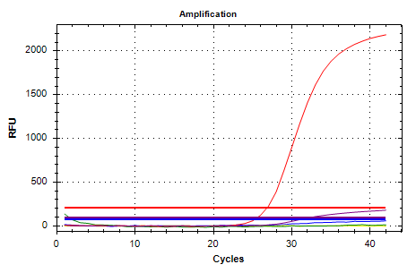
Texas Red = Red
FAM = Green
Cy5 = Purple → Background reaction

WARNINGS AND PRECAUTIONS
ViroQ® SC2 Variant 1 is designed for research use only and should be used by properly trained, qualified staff only. All work should be performed using Good Laboratory Practices.

The reagent ViroQ® Solvent is subject to hazardous substance labeling for Warning and Health hazard. Please refer to the table in Chapter 12 for more information.

Biological material used for extraction of RNA, e.g. respiratory specimen, should be handled as potentially infectious. When handling biological material appropriate safety precautions are recommended (do not pipet by mouth; wear disposable gloves while handling biological material and performing the test; disinfect hands when finished the test).

Biological material should be inactivated before disposal (e.g. in an autoclave). Disposables should be autoclaved or incinerated after use.

Spillage of potentially infectious materials should be removed immediately with absorbent paper tissue and the contaminated areas swabbed with a suitable standard disinfectant or 70% alcohol.
Material used to clean spills, including gloves, should be inactivated before disposal (e.g. in an autoclave).

Disposal of all samples, unused reagents and waste should be in accordance with country, federal, state and local regulations.

Microbial contamination of the reagents while taking aliquots should be avoided. It is recommended to use sterile one way pipettes and tips. Reagents that look cloudy or show any signs of microbial contamination must not be used.

A Material Safety Data Sheet resp. a declaration on Material Safety Data Sheets (MSDS) is available to download at www.bag-diagnostics.com.

LIMITATIONS OF THE METHOD
Mutations or polymorphisms in the primer and probe binding sites may cause false negative results.
Because of the high susceptibility of the RT-PCR method for cross contaminations special care should be taken during RNA isolation.
The presence of PCR inhibitors may cause invalid results with this product. A negative result does not exclude a possible detection of SARS-CoV-2 RNA and variants, as results are dependent on appropriate specimen collection and the absence of inhibitors.
Extreme care should be taken to prevent contamination of the kit reagents and other laboratory materials and equipment with amplicons, RNA or DNA. Regular wipe tests and negative controls with Aqua dest with each assay are strongly recommended.
In the negative control with Aqua dest. there must not be any fluorescent signal (Ct > N.A.).
In the case of signal development in the negative control please refer to Chapter 6.5 and and if necessary, decontaminate the PCR working place and exchange the reagents.
All instruments (e.g. pipettes, realtime cyclers) must be calibrated according to the manufacturers instructions.

INTERNAL QUALITY CONTROL
Internal quality control of new lots of the ViroQ® SC2 Variant 1 kit can be performed using a combination of RNA samples known to be positive or negative. Negative controls to detect possible contaminations are recommended. Use a PCR reaction with the RNase free water as a NTC for this purpose.

TROUBLESHOOTING
Symptom | Possible reason | Potential solution
Bad or no signal | Presence of an inhibitor. | Use fresh reagents.
Bad or no signal | No RNA in the reaction. | Repeat test. Take care of correct pipetting.
Bad or no signal | Fluorescent probes or primers degraded. | Use fresh Primer-Probe-Mix  Avoid exposition to light and frequent thawing and freezing. Observe storage conditions!
Bad or no signal | Bubbles in the PCR reaction, remaining liquid at the inner wall of the tube. | Careful pipetting.  Spin down PCR plate.
Bad or no signal | Incompatible or low quality RT-PCR plastic ware. | Use compatible and high quality plastic ware (see chapter 4.3).
Bad or no signal | Evaporation of the reagents due to incorrect closing of the PCR tubes. | Make sure that the PCR tubes are closed properly.  Be careful at the edges of sealing foils.
Signal in the negative control | Contamination with RNA or DNA in the negative control | Repeat the negative control.  Decontaminate the workplace.

TRADEMARKS USED IN THIS DOCUMENT/PRODUCT
TaqMan® is a trademark of Roche Molecular Systems Inc.
Cal Fluor® is a registered trade mark of LGC Biosearch Technologies

EXPLANATION OF SYMBOLS USED ON THE LABELS
 | Sufficient for n tests
 | Storage temperature / Lower limit of temperature
 | Use by
 | Consult instructions for use
 | Manufacturer
DRY | Dried
CONT | Content, contains
CONTROL | + | Positive control
IFU | Instructions for use
or | or
eIFU | Electronic instructions for use
LOT | Batch code
LYOPH | Lyophilized
REF | Catalogue number
RUO | For Research Use Only
ViroQ | ENZYME | Enzyme mix for ViroQ® products
ViroQ | MIX | Primermix for ViroQ® products
ViroQ | SOLV | Solvent for ViroQ® enzyme mix
 | Warning  H302: Harmful if swallowed.  H412: Harmful to aquatic life with long lasting effects.
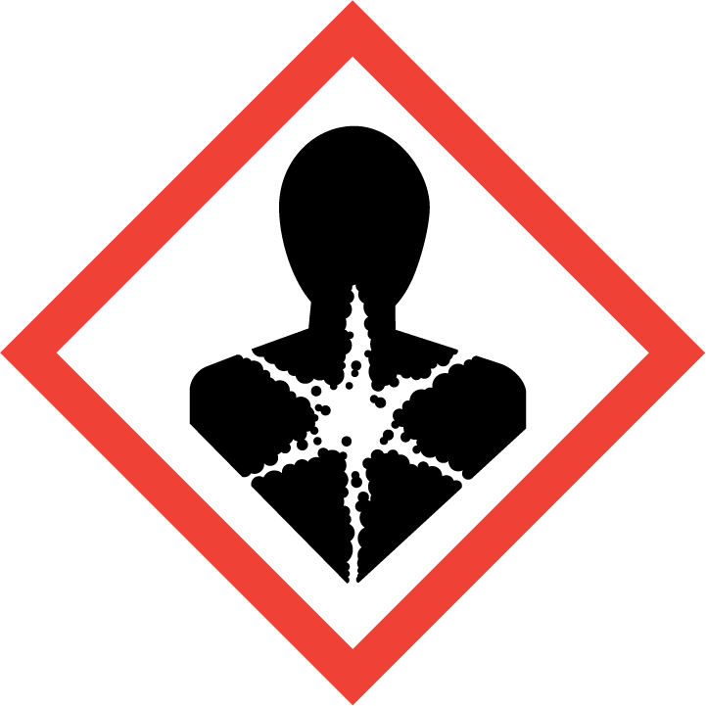 | Health hazard  H371: May harm the central nervous system. Route of exposure: Oral

LITERATURE
Emergence of SARS-CoV-2 B.1.1.7 Lineage — United States, December 29, 2020–January 12, 2021 https://dx.doi.org/10.15585%2Fmmwr.mm7003e2

Further information is provided on our website http://www.bag-diagnostics.com.
Instructions for use in other languages see: http://www.bag-diagnostics.com or contact us directly at info@bag-diagnostics.com or phone +49 (0)6404-925-125

